J-LINK EDU Mini SMD Adapter
(https://vi.aliexpress.com/item/1005004708738854.html?src=google&gatewayAdapt=glo2vnm)
- 10pin 1.27mm FFC Cable (Will connect with J-Link EDU Mini)
- 20pin 2.54mm FFC Cable (Will connect with our controller board)

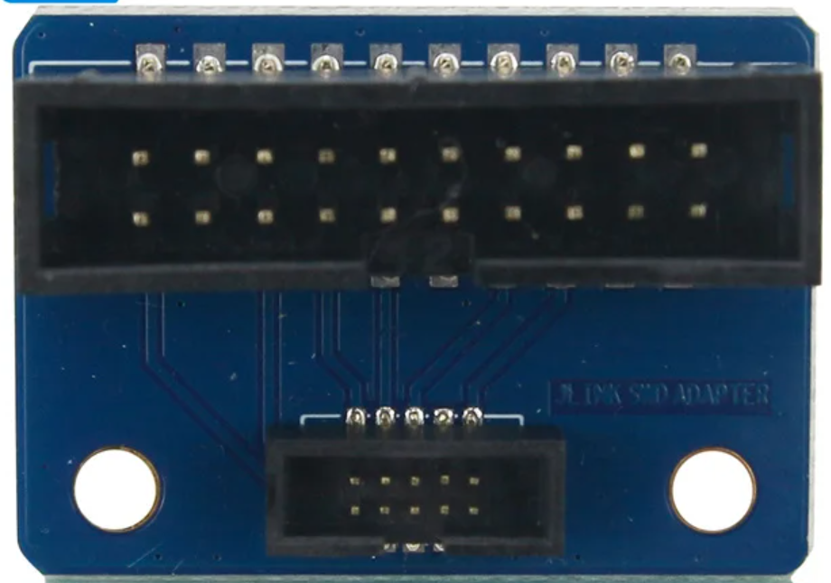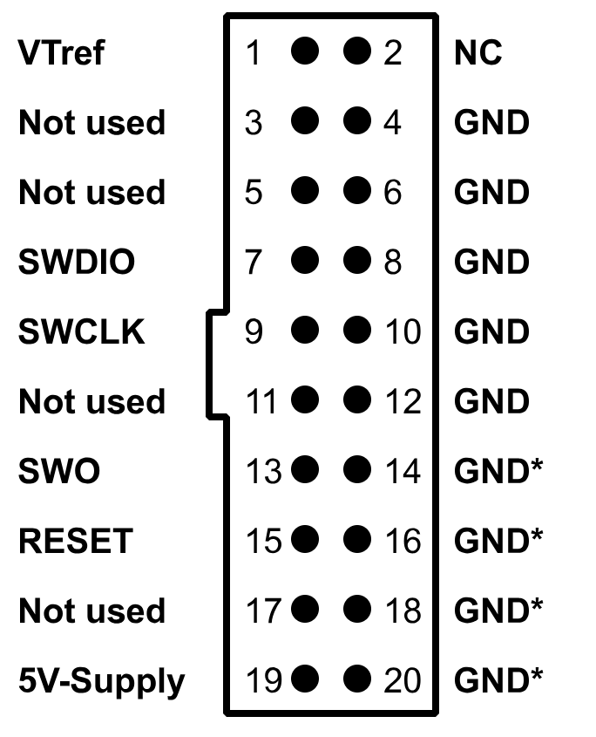

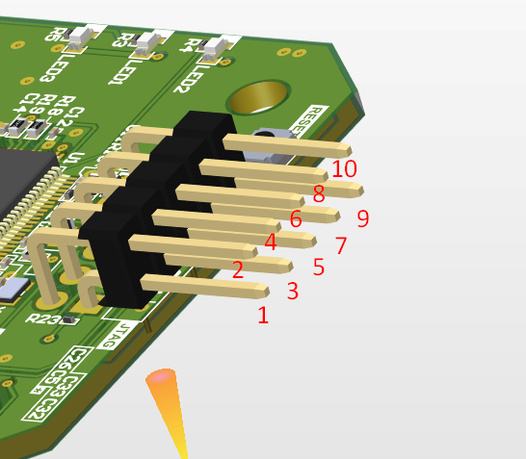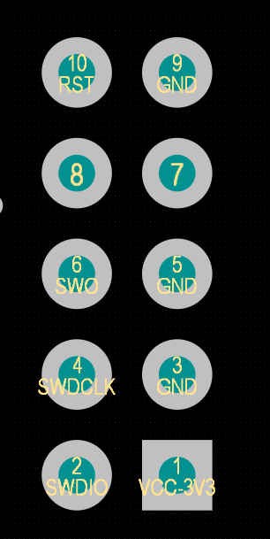

Make these connections between Adaptor and controller board;

Pin function | Header on adaptor | Header on controller board
VRef | Pin 1 | Pin 1
SWDIO | Pin 7 | Pin 2
SWCLK | Pin 9 | Pin 4
SWO | Pin 13 | Pin 6
RESET | Pin 15 | Pin 10
GND* | Pin 4, 6, 8, 10, 12 | Pin 3, 5, 9
* Connecting only one pin between the two headers is sufficient

